1.82: a) The angle between the vectors is 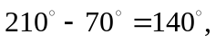 and so Eq. (1.18) gives Or, Eq. (1.21) gives
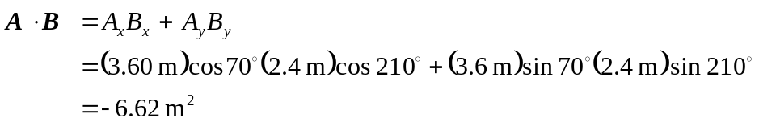

- From Eq. (1.22), the magnitude of the cross product is

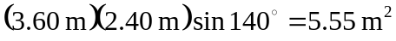,

and the direction, from the right-hand rule, is out of the page (the
+z-direction). From Eq. (1-30), with the z-components of 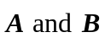 vanishing, the z-component of the cross product is

